**2019-20 K-12 Reclassification Rates by Grade**

**Axis labels: 0%, 20%, 40%, 60%, 80%, 100%**

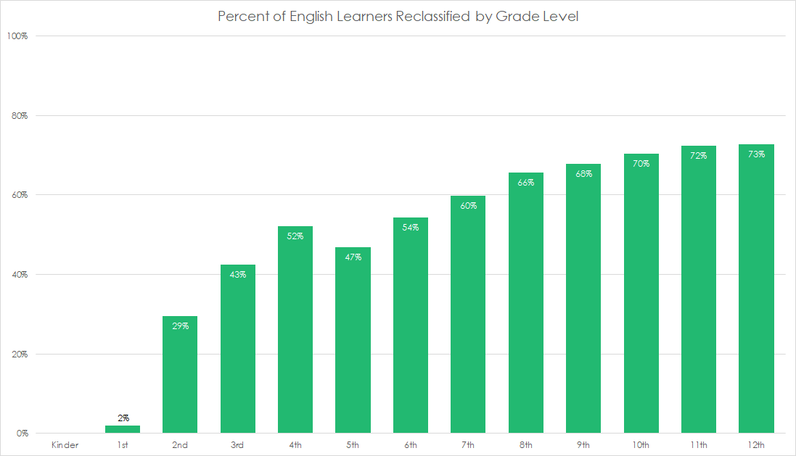

*Source: California Department of Education. (February 2021). 2019-20 "Ever-ELs" by Years as EL and Reclassification (RFEP) Status and Grade (Dataquest Report).*

Reclassification The process whereby a student is reclassified from English Learner status to fluent English proficient.

**2019-20 Percent of English Learners Reclassified by Grade Level**

|  |  |
| --- | --- |
| **Kinder** |  |
| **1st** | **2%** |
| **2nd** | **29%** |
| **3rd** | **43%** |
| **4th** | **52%** |
| **5th** | **47%** |
| **6th** | **54%** |
| **7th** | **60%** |
| **8th** | **66%** |
| **9th** | **68%** |
| **10th** | **70%** |
| **11th** | **72%** |
| **12th** | **73%** |

**Takeaways**

If English Learners have not reclassified by the time they leave elementary school, there is only a 50% chance that they will ever get reclassified while in Fresno public schools.

While Fresno public schools reclassify students in grades 2, 3, and 4 at a faster rate than the state of California, the data shows that more than a quarter of English Learners do not reclassify before leaving Fresno high schools.

**What committees can I join or what meetings can I attend to support English Learner outcomes?**

[**Consider joining an English Learner Advisory Committee (ELAC).**](https://els.fresnounified.org/elac/#who-can-serve-on-the-elac)Fresno Unified defines the ELAC as “a group of parents and community members who advise and assist schools in making important decisions related to services for English Learners.” **By law, an ELAC must be formed at any school that serves more than 20 identified English Learners.**

ELAC meetings are an excellent way to better understand the support English Learners receive at a given site. ELAC members also have the opportunity to give feedback on the school site’s academic service plan for English Learners.

[**Attend an LCAP meeting**](https://stafed.fresnounified.org/lcap/)**.** Every year, the district receives money specifically to help it better serve English Learners, low-income students, and foster youth. The Local Control and Accountability Plan (LCAP) is where the district explains how they are going to use that particular money. FUSD seeks community annual input on its LCAP and makes a set of revisions based on the feedback received before the next school year begins. These feedback sessions are a chance for the families of English Learners to learn more about the success and gaps in the current programming offered to their children and to advocate for what they want to be different in the coming year.